Dementia Oxfordshire Strengthen its Offline Connections Through Community Events
(For Immediate Release)
14/09/2022
As we move into autumn, Dementia Oxfordshire, a local service provided by Age UK Oxfordshire and Dementia UK, reflect on a summer full of awareness raising events across the county. Through a number of in-person events, they’ve been able to reach members of the community who are not active online or did not know about the service.
The team raised awareness both of dementia generally, and of what Dementia Oxfordshire can do to support both people living with dementia and their carers.
The busy summer kicked off in May, with a series of events for Dementia Action Week including Dementia Information Days in Cowley and Bicester. The team also attended local fetes including Chalgrove Festival and Witney Carnival. One of Dementia Oxfordshire’s charity partners, lettings agent Finders Keepers, have been raising awareness of the service through their fundraising activities at their Summertown offices and in Asda, Wheatley and Morrisons, Banbury.
Peter Johnson, Head of Service for Dementia Oxfordshire said, “It is crucial for us to have an online presence; however it is also important that we engage with people in more traditional ways, and whenever we can face to face. The events this summer have given us the opportunity to interact with people who have not come across our service before or who find it difficult to interact with us online. We support around 5000 people across the county, but we know there are more people out there eligible for our services.
It is also important that we continue to raise awareness about dementia. Many people with dementia want to live in and be an active part of their communities and the more we all understand about dementia the more we can all help them do that. “
Dementia Adviser, Rose Crozier, said, “Over the summer our team have answered lots of questions from the public, both about dementia and our service. We’ve built new connections with communities we work in and found new partners to work with. Our goal is to make sure everyone in Oxfordshire knows there are people available to support you on your dementia journey, it is not something you have to face alone.”
Dementia Oxfordshire look forward to continuing this work throughout the year. They will be at the Littlebury Hotel, Bicester on 14th October selling pre-loved jewellery and accessories to raise funds and awareness of Dementia Oxfordshire. Dementia Advisers will be on hand to answer any questions from members of the public or professionals.
Anyone can call the Dementia Oxfordshire Support Line to get advice, information and support from a Dementia Adviser. The support line is available 9am – 5pm, Monday to Friday on 01865 410 210.
ENDS
Images:
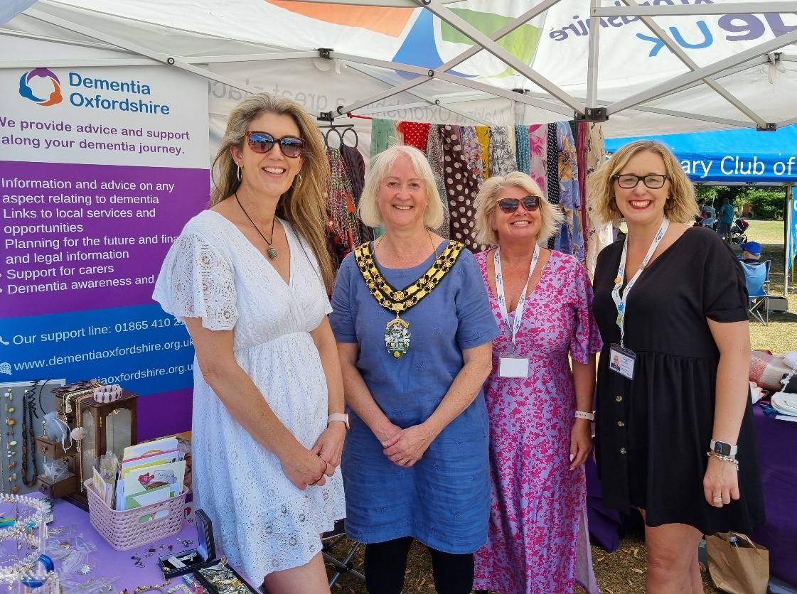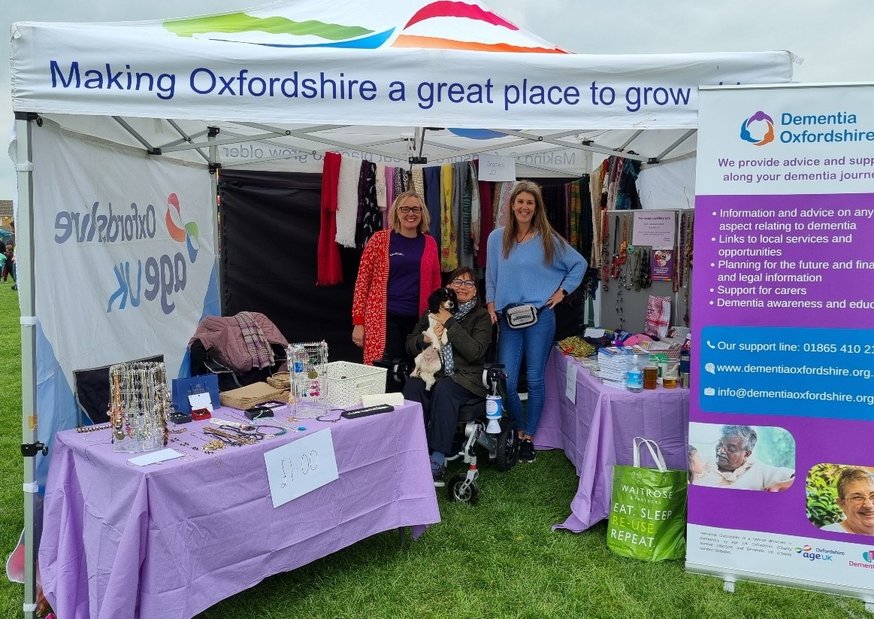

For media enquiries contact Lydia Rayden on hello@dementiaoxfordshire.org.uk 01235849415.
Notes to editor:
- Dementia Oxfordshire provides support and advice for people living with dementia and their families from the point of diagnosis until end of life or a move to a care home.
- The service supports people to live for as long as possible and as well as possible in the community, working to ensure people have a sense of meaning and purpose in their lives.
- There is no charge for the service and it is delivered in partnership by Age UK Oxfordshire and Dementia UK, combining our expertise to support people of any age with a diagnosis. - More information about our service can be found here: Dementia-Oxfordshire-Fact-Sheet-2.docx (live.com)

